SNJB’s Shri Hiralal Hastimal (Jain Brothers, Jalgaon) Polytechnic, Chandwad
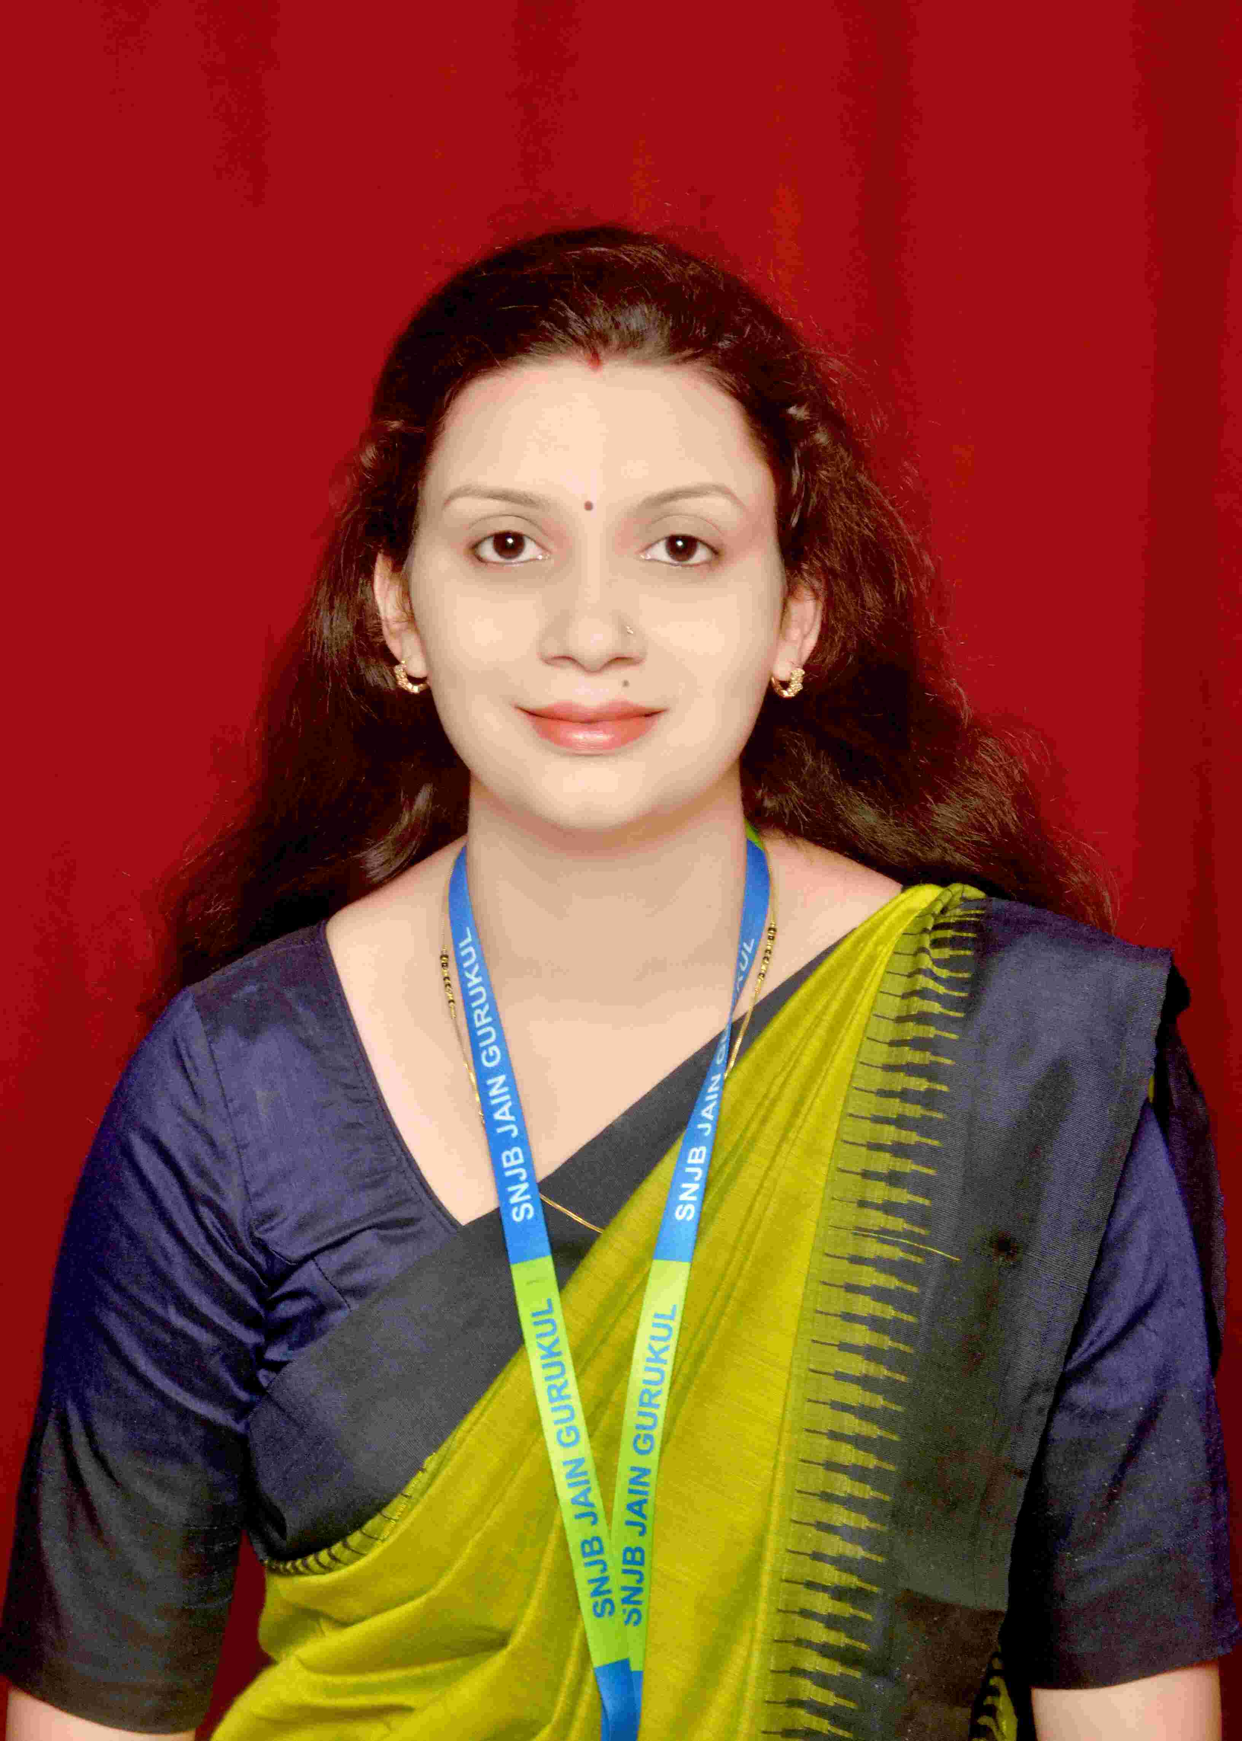
(All AICTE Approved Programs NBA Accredited)
Department: Computer Technology
Faculty Profile

Name of Faculty: Mrs. Lajima Shubham Bairagi

Qualification : | ME E&TC (Pursuing)
Designation : | Lecturer
Date of Joining : | 01/06/2024
Experience : | 2 Years 6 Months
Teaching/research Areas : | Computer Networks and Data Communication,  Consumer Electronics System,  Industrial Automation,  Python,  Embedded System
Courses / Subjects Taught : | Computer Networks and Data Communication,  Consumer Electronics System,  Industrial Automation,  Python
Staff training/FDP attended in last 3  Years | Innovative Technologies for Village Development  Inculcating Universal Human Values in Technical Education  Lean Manufacturing Practices  Web of things, machine learning & virtual lab  AI and Deep Learning for Biomedical Signal Processing: A MATLAB Approach
Paper presentation /conferences attended
Paper published in journals
Books published with ISSN/ISBN
number :
Participation in MSBTE activities (RAC/DC/Theory/PR Exam/Curriculum development)
List of Projects guided at diploma level last 3 years | Surveillance Drone with Landmine Detection  Voice Control Home Automation  Onion Health Monitoring  Smart Cleaning Bot
Role and responsibilities at institute  Level | Sports Committee Coordinator  Mentors Coordinator  Online Exam Coordinator
Role and responsibilities at  department level | Feedback Coordinator  Library Coordinator  NBA Criteria 3 & 7 Coordinator  SY Class Coordinator  Patent Coordinator  Parents Meet Coordinator
Major achievements in last 5 years | Certified as Lean Expert
Professional membership if any | -

